
QUALITY ALERT

Customer: ChamClad Date: May 30, 2023
Die: 15744 Color: Any
Type of Complaint: ChamClad REJECT Customer NCR:

Description: ChamClad REJECT – Material was waving when laminated – SEE REJECTED SAMPLE
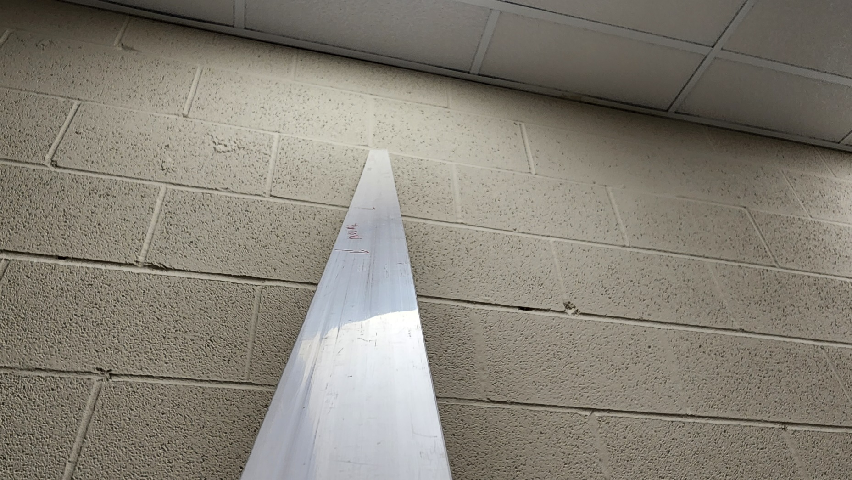

WAVING POINT

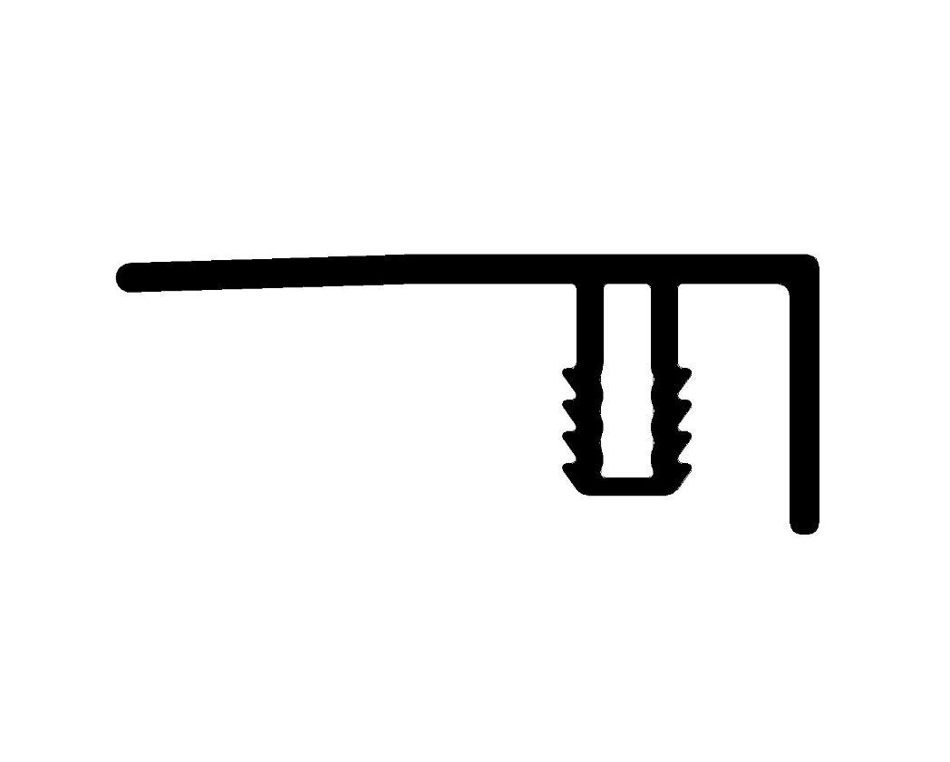

PLEASE CHECK CAREFULLY THE PIECE TO AVOID THIS ISSUE
BY SIGNING BELOW, YOU ACKNOWLEDGE THE PROBLEM ABOVE AND AGREE TO MONITOR THIS ISSUE IN FUTURE PRODUCTION RUNS.
DAY SHIFT |  | AFTERNOON SHIFT |  | NIGHT SHIFT
NAME | SIGNATURE | NAME | SIGNATURE | NAME | SIGNATURE

